Resource Pack for the Economics Curriculum (Secondary 4-6)
Personal, Social and Humanities Education Section
Curriculum Development Institute
Education Bureau
2023

Financial Technology Innovations: Cryptocurrency and Virtual Banking

Preface
Cryptocurrency and virtual banking are two financial technology (fintech) innovations that are changing our lives and the economy as a whole. The Education Bureau publishes this resource pack to support the learning and teaching of the concepts related to these two fintech innovations in the Economics Curriculum (S4-6). The Pack includes introductions to these two fintech innovations and analyses of their economic implications.

It is our honour to have Dr. Lee Shu Kam, Director of Business, Economic and Public Policy Research Centre, Hong Kong Shue Yan University to develop this resource pack for the Education Bureau. If you have any comments or suggestions about this Pack, please send them to:

Chief Curriculum Development Officer (Personal, Social and Humanities Education) 1
Curriculum Development Institute
Education Bureau
Room 1319, 13/F., Wu Chung House
213 Queen’s Road East, Wanchai, Hong Kong
E-mail: info_pshe@edb.gov.hk

Contents
Contents | Page
Section I: Cryptocurrency
i. Bitcoin | 3
ii. Bitcoin and Other Cryptocurrencies | 4-7
iii. Supply of Bitcoin | 7
iv. Is Bitcoin a medium of exchange in Hong Kong? | 8
v. Other Issues of Bitcoin | 9-10
vi. Value of Bitcoin | 10-11
Section II: Virtual Banking
i. The Banking Industry in Hong Kong | 12
ii. Embracing Fin Tech | 12
iii. The Introduction of Virtual Banks | 12-14
iv. The Introduction of Virtual Insurance Company | 14-15
v. Fin Tech and Productivity | 15-16
vi. Fin Tech and Employment | 17-23
Section III. Selected Information for the Topic and Q&A | 24-26
Reference Websites for this Topic | 27

Financial Technology Innovations: Cryptocurrency and Virtual Banking
Section I: Cryptocurrency
- Bitcoin
A cryptocurrency is a digital or virtual currency that is secured by cryptography, the science of coding and decoding messages and data to secure them, making it nearly impossible to counterfeit or double-spend. Bitcoin is often described as a cryptocurrency or a virtual currency because it does not have a physical form - a type of money that is completely virtual. It is like an online version of cash. People can use it to buy products or services from the merchants who accept them. But unlike traditional currencies, Bitcoin is not backed by any bank or government, nor supported by its issuers. In Hong Kong, Bitcoin and other “cryptocurrencies” are virtual commodities and are not legal tenders. Its usage is limited as not many shops accept Bitcoin yet and some countries have banned it altogether.
Bitcoins can be acquired and sold through Bitcoin trading platforms, and they can be transferred digitally via mobile apps and computers. Bitcoin can be stored in a digital wallet, in a cloud or on a user’s computer. Every single transaction is recorded in a public list called the blockchain. This makes it possible to trace the history of Bitcoins to stop people from spending coins they do not own, making copies or undoing transactions. Whenever a new block of transactions is created, it is added to the blockchain. Transactions are verified by other Bitcoin users (known as miners) who may earn a reward in Bitcoins for this service. This verification and reward process is known as Bitcoin mining. However, there is a limit of 21 million Bitcoins people can mine. As it is approaching that number, it would become harder and harder to create or mine one more Bitcoin. If starting mining now, it could be years before getting a single Bitcoin. One could end up spending more money on electricity for your computer than the Bitcoin would be worth. That is why it is impossible to devalue cryptocurrency in the same way as for paper money by just printing many of those.
The goal of Bitcoins is to create a decentralized worldwide digital currency. It means that Bitcoin is not controlled by the government or banks. People can spend Bitcoins anonymously. Although all transactions are recorded, nobody would know who is associated with the Bitcoin address (analogous to a bank account number) unless being told specifically. So now someone can buy things and exchange money from anyone anywhere in the world with Bitcoin without worrying about exchange rates or banks or borders. The decentralization of Bitcoin blockchain means that the Bitcoin network does not have any central points of control (like a central bank); nor does it have any central points of transaction storage (a central database storing all the Bitcoin transaction records). The Bitcoin blockchain operates over a global network with thousands upon thousands of nodes (machines running the Bitcoin software). These machines together verify and store transactions.
The blockchain technology makes it possible to have a common record of all the transactions in thousands of nodes, while preventing the double-spending problem in the Bitcoin network and makes it extremely difficult to alter historical transactions. The double-spending problem is a potential flaw in a cryptocurrency in which a payer can spend the same digital token more than once. Due to the decentralized nature, it is very hard to shut down or interfere with the Bitcoin network by the government.
Since every transaction is recorded publicly, it is very difficult to copy Bitcoins, make fake ones or spend ones without owning them. However, it is possible to lose Bitcoin wallet, and thus lose Bitcoins forever. There have also been thefts from websites that store Bitcoins remotely.
- Bitcoin and other cryptocurrencies
Bitcoin is the first established cryptocurrency in the world. After its success, many other alternative cryptocurrencies rose. As of 20 Nov 2022, there are more than 19,000 cryptocurrencies in the world. Nevertheless, Bitcoin is still the leader in this space. With its total market capitalization (the total market value of the underlying asset in US dollar, i.e., outstanding quantity times market price) of more than USD 318 billion, Bitcoin shares more than 40% of the total market capitalization of all cryptocurrencies.

Figure 1: Some data about Bitcoin
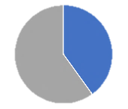
38%
$ 318 Billion
Data Source: CoinMarketCap as of 20 Nov 2022

Figure 2: Percentage of Total Market Capitalization of Cryptocurrencies of Bitcoin as of 20 Nov 2022

Data Source: CoinMarketCap as of 20 Nov 2022

Figure 3: Number of Bitcoin Daily Transactions from Jan 2009 to Nov 2022

Number of Bitcoin Daily Transactions
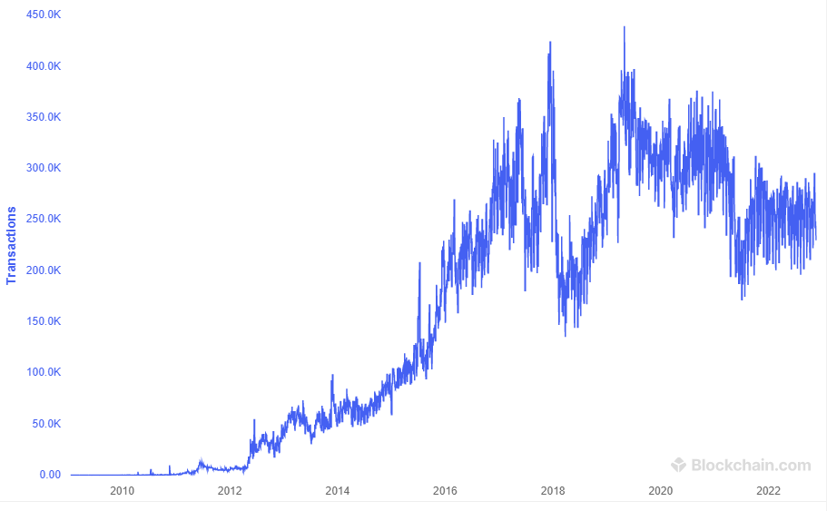
Source: blockchain.com
The future of Bitcoin and cryptocurrencies is uncertain. They are still in the experimental stage and constantly evolving. The acceptance of cryptocurrencies remains uncertain worldwide and their value tends to be highly speculative and volatile. Consumers should be cautious when considering to use, trade or invest in cryptocurrencies.
[Remark: Bitcoin is not a legal tender in Hong Kong. HKSAR Government has issued a policy statement on the development of virtual assets (VA) in Hong Kong on the 31st October 2022, which sets out its policy stance and approach towards developing a vibrant sector and ecosystem for VA in the city. A regulatory regime has been launched to license VA Exchanges using an “opt-in” approach, and on the asset management front guidance has been issued on management of VA funds and discretionary accounts. Also, banks and financial institutions have been provided guidance on distribution of VA-related products, dealing in or advising on VAs. These comprehensive regulatory regimes have been well received by the industry. Besides, the Hong Kong government’s latest effort is to put together a licensing regime for VA Service Providers. The new regime will align requirements for VA Exchanges in terms of anti-money laundering, counter-terrorist financing (“AML/CTF”), and investor protection to those currently applicable to traditional financial institutions, hence offering licensed VA Exchanges the status and credibility to access a wider net of investors in the Hong Kong market. Details of the policy statement on the development of virtual assets (VA) in Hong Kong could be found at https://www.news.gov.hk/eng/2022/10/20221031/20221031_102428_003.html]
- Supply of Bitcoin
Scarcity is an important characteristic of money.
Bitcoin was born out of the 2008 global financial crisis when global central banks began to massively print money (quantitative easing). Bitcoin was proposed as an alternative currency and electronic payment system, in which users do not need to trust a central authority behind. The supply of Bitcoin is predetermined and thus removes the need for a central institution to actively manage the supply and its value.
Bitcoins are created by a decentralized process called “mining” to reward Bitcoin miners for spending computing power to verify transactions and secure the network. This process is decentralized in the sense that anybody can become a Bitcoin miner by running software with specialized hardware, and no individual has control over the network. Anybody can set up machines to run the Bitcoin software to help process Bitcoin transactions for everybody. The machines are made to work out incredibly difficult sums. Occasionally these machines are rewarded with some amount of Bitcoin for the owner to keep. The sums are becoming increasingly difficult in order to slow down the creation of Bitcoin.
The number of Bitcoins generated is programmed to decrease geometrically, with a 50% reduction in reward for approximately every four years until the Bitcoin issuance halts completely when a fixed hard limit of 21 million Bitcoins have been created.
Compared to the money supply (M1) of the United States Dollar (USD), the quantity of Bitcoin is growing at a much slower rate. Interestingly, the growth rate of Bitcoin is deterministically scheduled to gradually slow down until the hard-cap of 21 million Bitcoins is reached.

Figure 4: Money Supply M1 in the United States from January 2020 to Oct 2022
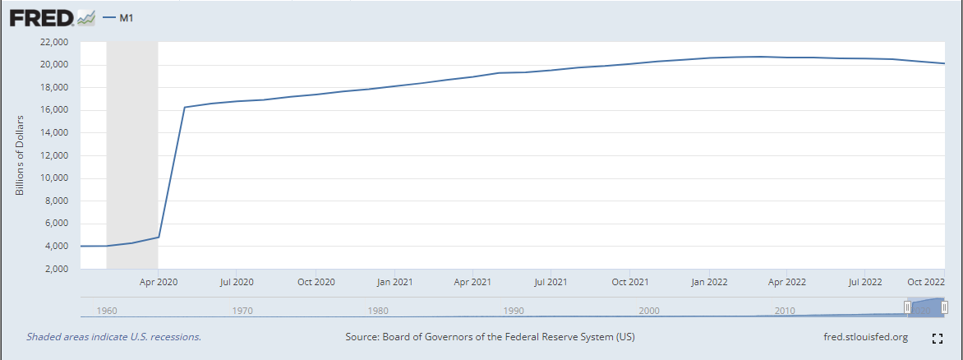
Source: Federal Reserve Bank of St. Louis

- Is Bitcoin a medium of exchange in Hong Kong?
International payments using Bitcoins are easy and fast. The transaction fees therein are unrelated to the amount transferred and hence may be lower than that in conventional payment systems.
Bitcoin could be used to buy games, movies, and apps from giant companies like Microsoft. In some countries/regions, people could buy home furnishings, computer hardware or digital camera, or even order dinners with Bitcoin. With the help of Bitcoin payment processing companies, it’s becoming easier for businesses to accept payments in Bitcoin (or other cryptocurrencies) for their products or services. It might seem that Bitcoin could be used as a medium of exchange.
When taking a closer look, however, usage of Bitcoin or alternative cryptocurrencies in Hong Kong is still very limited. They are not widely accepted at all as a means of payment. A study revealed that in the first four months of 2019, only 1.3% of transactions of Bitcoins came from merchants. It may partly due to the fact that it requires a relatively high level of computer knowledge to understand and use Bitcoin. In fact, the Bitcoin software is still under ongoing development.

- Other Issues of Bitcoin
What would be the impacts on an economy if cryptocurrencies like Bitcoin are adopted as currency? Due to the fixed supply schedule in Bitcoin, the risk of structural deflation is an issue., The expectation of a higher purchasing power in the future could incentivize people to hold Bitcoin instead of spending it, and thus suppress consumption and economic growth.
Bitcoin is a cryptocurrency without an intrinsic value and hence is based on trust that it will be valuable and accepted as a medium of exchange also in the future. The demand for commodity currency is driven by both its intrinsic value and its value in future exchange, whereas the demand for Bitcoin is driven by its value in future exchange. Positive and negative news cause a large fluctuation in demand in Bitcoin. Moreover, the supply of Bitcoin is limited and capped. The highly inelastic supply of Bitcoin results in higher sensitivity of Bitcoin value in response to change in (Bitcoin) demand. Prices of Bitcoin-denominated products or services will, therefore, become more volatile. Wealth stored in the form of Bitcoin could therefore become more unstable, which is not uncommon in its history.
Also, without the control over Bitcoin supply, the government is less able to smooth the business cycle by responding to shocks to money demand or conducting expansionary or contractionary monetary policy to stabilize the economy.
While Bitcoin successfully removes the need to trust a central authority and prevents over-issuance of money and hence inflation, the inflexibility in its supply causes other problems. Apart from its inflexible supply, Bitcoin is also criticized for its use in illegal activitiesand its high energy consumption for mining Bitcoin.
Other digital currencies are proposed and developed to address the problems in Bitcoin. Libra proposed by Facebook, for example, is a cryptocurrency designed to have a more stable value, as backed by reserves of cash or cash equivalents and assets of different currencies. Many central banks have also been researching on issuing their state-run digital currency, or Central Bank Digital Currency (CBDC). For example, China’s sovereign digital currency, Digital Currency Electronic Payment (DCEP), is already in the testing phase.

- Value of Bitcoin
As of 30 April 2022, the price of a Bitcoin is USD 37,714.88. The smallest unit of Bitcoin is satoshi, named after Satoshi Nakamoto, the creator of Bitcoin. There are 100,000,000 satoshis in 1 Bitcoin. As of 30 April 2022, 1 US cent is worth approximately 26 satoshis.

The figures below show the prices of Bitcoin from Dec 2014 to Nov 2022.

As mentioned above, the price of Bitcoin has been highly volatile in recent years, especially after its popularity in early 2017. The increased popularity of the cryptocurrency, however, made its value more unstable. There are often significant rises and falls in Bitcoin price, as compared to Gold and the USDEUR foreign exchange rate.

Figure 5: Bitcoin Price - Dec 2014 to Nov 2022
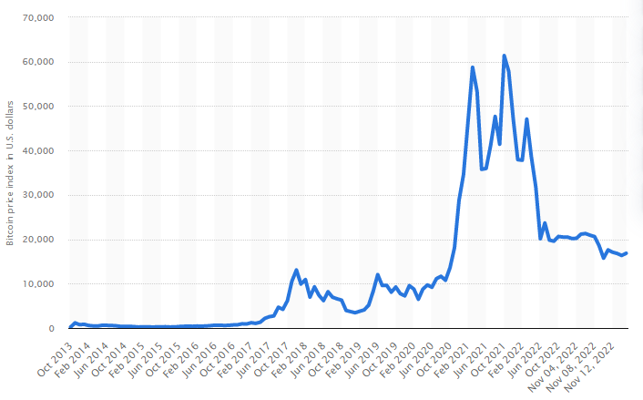
Source: Statistia (https://www.statista.com/statistics/326707/bitcoin-price-index/)

Figure 6: Monthly Rate of Change (%), Bitcoin, Gold Price and USDEUR FX Rate, Jan 2019 – Mar 2020
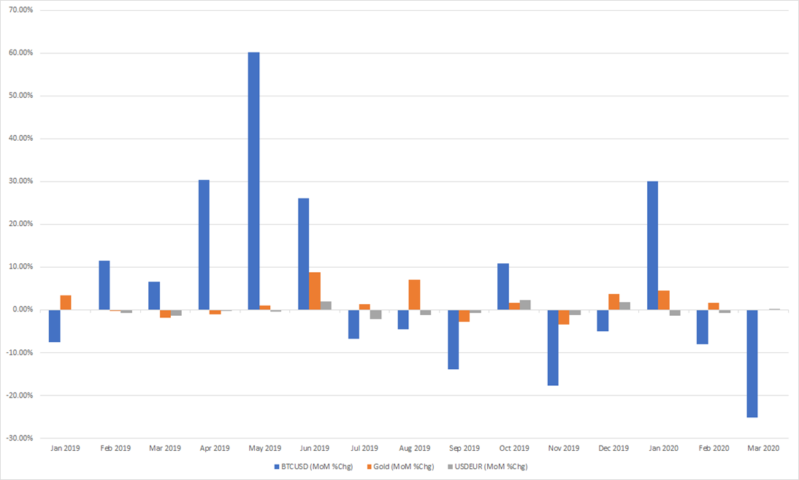
Source: World Gold Council , Federal Reserve Board, CoinMarketCap
Section II: Virtual Banking
- The Banking Industry in Hong Kong
The banking industry is very important in the economy of Hong Kong. In 2018, the financial services sector contributed around 20% GDP (Gross Domestic Product) of Hong Kong. In the same year, the banking industry accounted for 40% and 66% respectively of the total employment and value-added in respect of the entire financial services sector.

- Embracing FinTech
Financial technology or fintech covers the application of artificial intelligence, blockchain, cloud computing, and big data in areas such as payments, clearing and settlement, deposits, lending and capital raising, insurance, investment management, and market support.
In 2016, HKMA established the Fintech Facilitation Office (FFO) to facilitate the healthy development of the ecosystem of fintech in Hong Kong and promote Hong Kong as a fintech hub in Asia.
Further, in September 2017, the HKMA announced several initiatives to prepare Hong Kong to move into a new era of Smart Banking to help the banking industry to capture the opportunities brought about by the convergence of banking and technology. The introduction of virtual banks is one of the important initiatives to promote Smart Banking.

- The Introduction of Virtual Banks
On 30 May 2018, the HKMA published a revised Guideline on Authorization of Virtual Banks (Guideline) to facilitate the introduction of virtual banks. The guideline sets out the principles which the authority will take into account in deciding whether to authorize virtual banks.
Virtual banks are banks which primarily deliver retail banking services through the internet or other forms of electronic channels instead of physical branches. According to the Hong Kong Monetary Authority, as of 31 Oct 2022, there were 8 virtual banks in Hong Kong:
- AIRSTAR BANK LIMITED
- ANT BANK (HONG KONG) LIMITED
- FUSION BANK LIMITED
- LIVI BANK LIMITED
- MOX BANK LIMITED
- PING AN ONECONNECT BANK (HONG KONG) LIMITED
- WELAB BANK LIMITED
- ZA BANK LIMITED

These banks are required to comply with the same regulations as conventional banks. They are also members of the Hong Kong Deposit Protection Board. This means each depositor of these banks is entitled to deposit protection of up to HKD 500,000.
How are they different from conventional banks? Virtual banks deliver all services via the internet. For example, using a mobile phone, clients can access the mobile app or the website of a virtual bank, scan proof of identity, take a selfie and then submit certain personal information, and the account opening procedure is basically completed. They do not impose minimum balance requirements or low-balance fees on customers and therefore promote financial inclusion. Furthermore, without the costs of operating retail physical branches, the cost of operations can be lowered, and therefore it is more likely for these virtual banks to have more attractive offers for their customers, such as higher saving interest rates.
While conventional banks are open to adopting a wide range of fintech innovations, virtual banks are more eager to apply most of these innovations in almost all the services they plan to offer.

Figure 7: FinTech Application Status by Incumbent Banks in Hong Kong
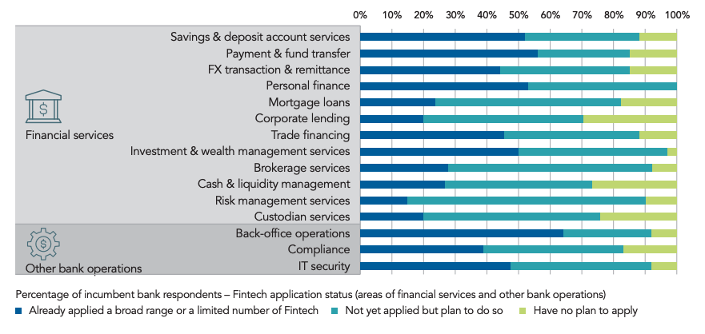
Source: Hong Kong Institute for Monetary and Financial Research (HKIMR)

Figure 8: FinTech Application Status by Virtual Banks in Hong Kong
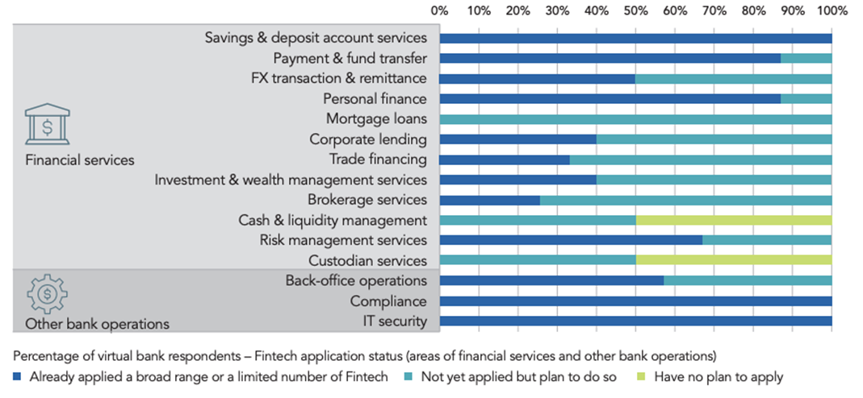
Source: HKIMR

- The Introduction of Virtual Insurance Company
Fintech advancement is also happening in the insurance sector. In September 2017, the Insurance Authority launched the Fast Track to provide a dedicated queue for companies to enter the Hong Kong insurance market using only digital distribution channels. As of 30 April 2022, there were four virtual insurance companies granted authorization under the Fast Track. Mr. Clement Cheung, Chief Executive Officer of the Insurance Authority, said that these virtual insurers could accelerate the Fintech development in Hong Kong and bolster Hong Kong’s competitiveness as an innovation hub.
- FinTech and Productivity
Preliminary findings of a research conducted by Hong Kong Institute for Monetary and Financial Research (HKIMR) suggest that the adoption of fintech has positive effects on banks’ performance. The results show that changes in banks’ cost-to-income ratio and return on assets (ROA) are statistically correlated with fintech adoption status. Figure 9 shows that, other things equal, a bank with a higher level of fintech adoption is associated with a larger cumulative decline in its cost-to-income ratio. A decline in the cost-to-income ratio means the bank is running more profitably. Figure 10 shows that, other things equal, a bank with a higher level of fintech adoption is associated with a larger cumulative rise in its Return on Assets, a profitability measure of how efficient a bank can generate profits from its assets.

Figure 9: FinTech’s Positive Effects on Banks’ Performance – Change in cost-to-income Ratio
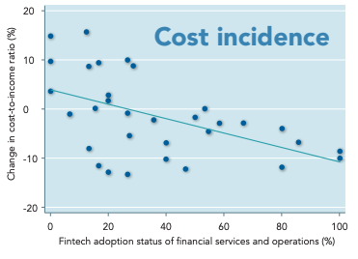
Source: HKIMR

Figure 10: FinTech’s Positive Effects on Banks’ Performance – Change in Return on Assets
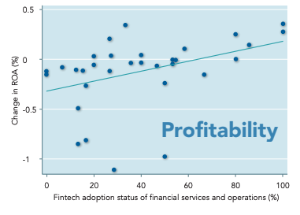
Source: HKIMR
The banking industry has been one of the key drivers of the productivity growth of Hong Kong. According to Figure 11, in the period 2000 – 2013, the measure of total factor productivity (TFP) increased 2.7% on average. Banks’ TFP growth has remained highly resilient and contributed stably to the overall TFP growth of the economy.

Figure 11: TFP Growth of Major Economic Sector
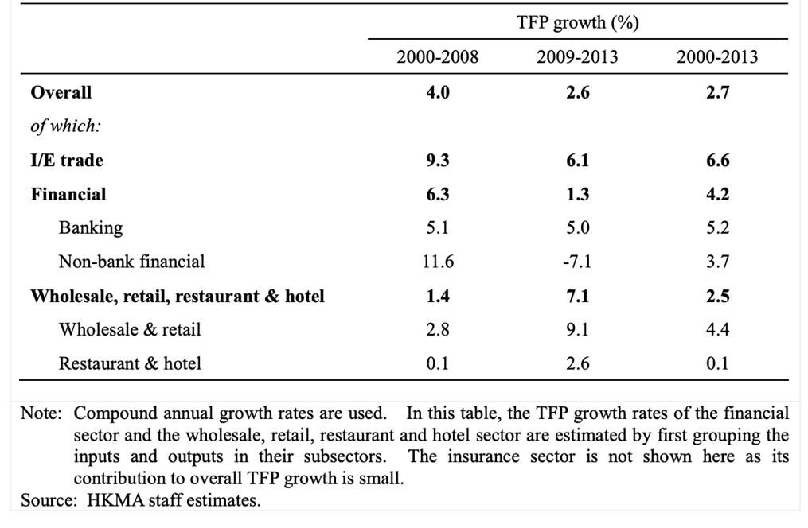
Source: HKMA

- FinTech and Employment
As one of the pillars in the Hong Kong economy, the banking sector contributed to around 3% (100,200 persons) of total employment in Hong Kong in 2020. The future development of the banking sector has an impact on the employment situation in Hong Kong.
The development of fintech and the introduction of virtual banks will have an impact on the manpower requirements in the future. The manpower requirements of the banking sub-sector are projected to increase by 0.7% annually on average from 2017 to 2027. Comparatively, the manpower requirements in the information technology and information services industry and the innovation and technology industries are projected to grow at an average annual rate of 2.2% and 4.3% respectively.
Consistent to the expectation that, with the advancement and increasing adoption of fintech, the banking sector would become increasingly more professional, demanding more high-skilled labours, the projected manpower requirements of the banking sector by education level shows a clear pattern that the demand for workers with higher education level is higher than those with lower education level. In fact, the manpower requirements of education level below first degree are projected to be declining.
Table 1: Manpower Requirements of the Financial Services Sector and its Sub-sectors in 2017 and 2027
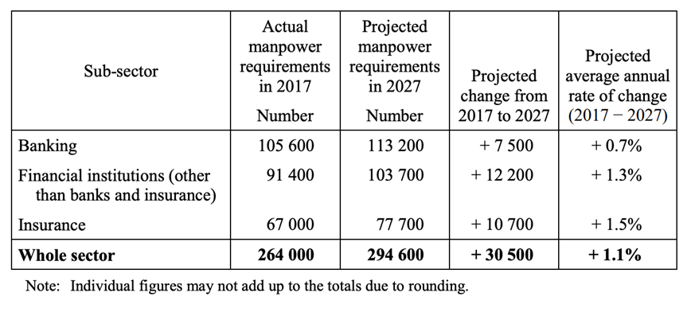
Source: Census and Statistics Department

Table 2: Manpower Requirements of the Selected Industries in 2017 and 2027
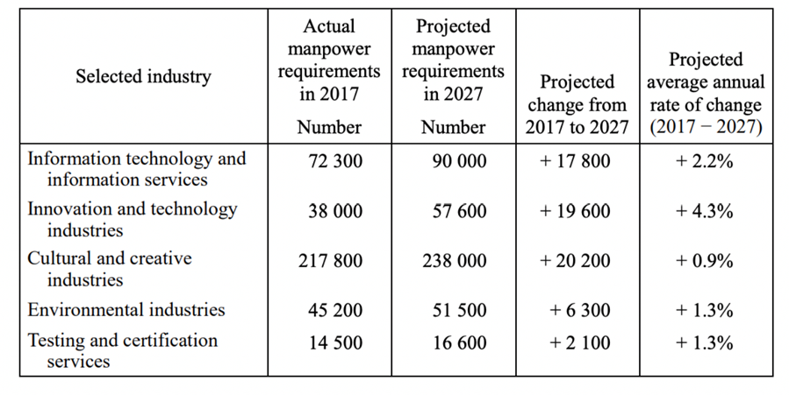
Source: Census and Statistics Department
Table 3: Manpower Requirements of the Banking Sub-sector by Education Level in 2017 and 2027
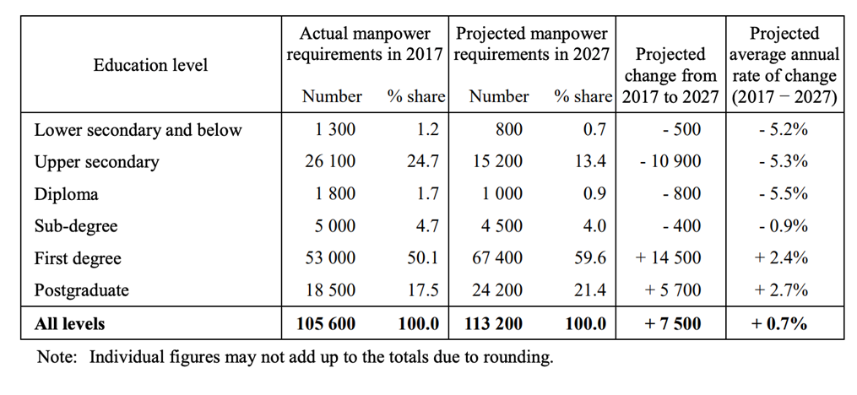
Source: Census and Statistics Department

Section III. Selected Information for the Topic and Q&A
Source A: Description of Bitcoin
Bitcoin uses peer-to-peer technology to operate with no central authority or banks; managing transactions and the issuing of Bitcoins is carried out collectively by the network.
(Source: Bitcoin Project (n.d.) Bitcoin – Open source P2P money. https://Bitcoin.org/en/)

Source B: Some information about Bitcoin in Hong Kong
In Hong Kong, Bitcoin and other “cryptocurrencies” are considered to be virtual commodities and are not legal tenders. Usage is limited as they are not widely accepted as a means of payment or recognized as a digital currency.
(Source: Investor and Financial Education Council (n.d) Basic concept - Bitcoin/ “cryptocurrencies”. https://www.ifec.org.hk/web/en/financial-products/fintech/ico-Bitcoin/basic-concept-Bitcoin.page)

Source C: A news article about Bitcoin usage
Expedia started accepting Bitcoin for hotel payments in 2014, and for a long time they were a prime example of mainstream cryptocurrency usage. Unfortunately, this story came to a sad ending when the company decided to stop accepting Bitcoin in the summer of 2018.
(Source: Luke Fitzpatrick (2019, May 7) Expedia: A Cautionary Tale For Cryptocurrency In Travel. Forbes. https://www.forbes.com/sites/lukefitzpatrick/2019/03/07/expedia-a-cautionary-tale-for-cryptocurrency-in-travel/#6f7aaf02f0b9)

Source D: Bitcoin Price (in USD) – March 6, 2020 – March 12, 2020
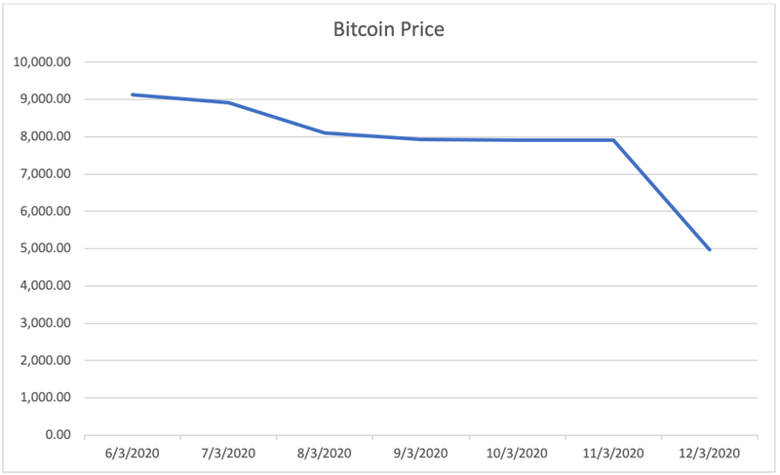
(Source: CoinMarketCap (2020) Bitcoin (BTC) historical data. https://coinmarketcap.com/currencies/Bitcoin/historical-data/)

Source E: Description of the supply of Bitcoin
Bitcoins are created at a decreasing and predictable rate. The number of new Bitcoins created each year is automatically halved over time until Bitcoin issuance halts completely with a total of 21 million Bitcoins in existence. The supply of Bitcoin is estimated to grow about 2.5% in 2020 and below 2% in 2021, on the way to zero growth.
(Source: Bitcoin Project (n.d.) Frequently Asked Questions. https://Bitcoin.org/en/faq#economy; McGlone, M. (2020, January 7) Bitcoin, gold set for 2020 growth on fixed supply, more adoption Bloomberg Intelligence https://www.bloomberg.com/professional/blog/Bitcoin-gold-set-for-2020-growth-on-fixed-supply-more-adoption/)

Source F: A news article about Bitcoin trading activities
“Bitcoin economic activity continues to be dominated by exchange trading,” Kim Grauer, senior economist at Chainalysis, said in an email. “This suggests Bitcoin’s top use case remains speculative, and the mainstream use of Bitcoin for everyday purchases is not yet a reality.”
(Source: Kharif, O. (2019, May 31) Bitcoin's Rally Masks Uncomfortable Fact: Almost Nobody Uses It. Bloomberg. https://www.bloomberg.com/news/articles/2019-05-31/Bitcoin-s-rally-masks-uncomfortable-fact-almost-nobody-uses-it?srnd=cryptocurrencies)

Source G: Unit of Bitcoin
The satoshi is currently the smallest unit of the Bitcoin currency. It is a one hundred millionth of a single Bitcoin (0.00000001 of a Bitcoin).
(Source: Bitcoin Wiki (n.d.) Satoshi (unit). https://en.Bitcoin.it/wiki/Satoshi_(unit))

Source H: Faster Payment System (FPS)
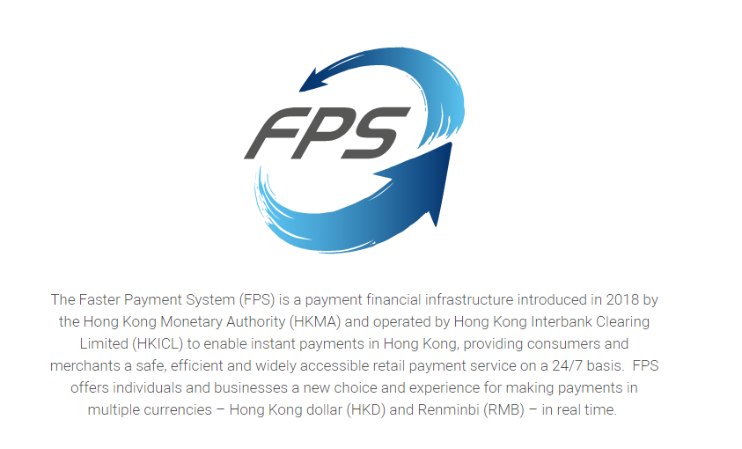
(Source: Hong Kong Interbank Clearing Limited (n.d.) FPS. https://fps.hkicl.com.hk/eng/fps/index.php)

Source I: A news article about the usage of the Faster Payment System (FPS)
Hong Kong residents can expect to benefit from cheaper and better banking services with the launch of more virtual banks this year, according to high-profile speakers at the Asian Financial Forum.
Their comments came as it was revealed the Hong Kong Monetary Authority has hit an important milestone in its efforts to promote financial technology (fintech). Half the population of the city has now signed up to its Faster Payment System, which enables the free transfer of money between bank accounts via mobile phone.
(Source: Yiu, E. (2020, January 13) Business / Banking & Finance Hong Kong hits major FinTech milestone as half the city’s population signs up for HKMA’s Faster Payment System. South China Morning Post. https://www.scmp.com/business/banking-finance/article/3045893/hong-kong-hits-major-fintech-milestone-half-citys)

Source J: The Introduction of Virtual Banks
A virtual bank is defined as a bank which primarily delivers retail banking services through the internet or other forms of electronic channels instead of physical branches.
The introduction of virtual banks in Hong Kong is a key pillar supporting Hong Kong’s entry into the Smart Banking Era. The HKMA believes that the development of virtual banks will promote fintech and innovation in Hong Kong and offer a new kind of customer experience. In addition, virtual banks can help promote financial inclusion as they normally target the retail segment, including the small and medium-sized enterprises (SMEs).
(Source: Hong Kong Monetary Authority (2020) Virtual Banks. https://www.hkma.gov.hk/eng/key-functions/banking/banking-regulatory-and-supervisory-regime/virtual-banks/)

Source K: A news article about banking sector hiring situation
Employers are now looking for more data scientists and full-stack developers for mobile and web applications that go beyond the traditional set of tech skills. With eight virtual bank licenses issued in 2019, it is no understatement to say that a real hiring race is underway for virtual banking talent.
Firms, in particular, have been looking for IT directors and IT managers to lead their growing tech teams. However, key tech talents have moved away from the traditional set of skills as the FinTech race heats up, especially after banks realised that most of the upcoming virtual banks were backed by the major financial firms.
(Source: Punay, N. (2019, August 26) Virtual bank data scientists are driving bank hiring. Hong Kong Business. https://hongkongbusiness.hk/financial-services/in-focus/virtual-bank-data-scientists-are-driving-bank-hiring)

Suggested Questions based on the above Sources
(According to the level of difficulty, the questions below are divided into three levels i.e. elementary, medium and advanced.)

Elementary Level
- Refer to Source C. Which property of money does Bitcoin lack?
Suggested Answer:
Bitcoin lacks general acceptability.

- Refer to Source D. Briefly describe the trend of Bitcoin price during the period.
Suggested Answer:
The price of Bitcoin was falling during the period.

- Refer to Source E. Briefly describe the trend of the quantity and growth rate of Bitcoin.
Suggested Answer:
The quantity of Bitcoin was increasing. However, the growth rate of the quantity was decreasing.

- Refer to Source G. How many satoshis in 10 Bitcoins? In terms of properties of money, how does this make Bitcoin potentially more useful to be used as money?
Suggested Answer:
There are 1 billion satoshis in 10 Bitcoins. This suggests that Bitcoin is divisible, and this property allows it to be used to pay for smaller size or quantity of goods or services.

Medium Level
- Refer to Source E and Source F. Explain in terms of price elasticity of supply why the price of Bitcoin would be more volatile compared to other commodities.
Suggested Answer: The demand for Bitcoin is mainly driven by speculation.
The highly inelastic supply of Bitcoin results in higher sensitivity of price in response to change in demand.,
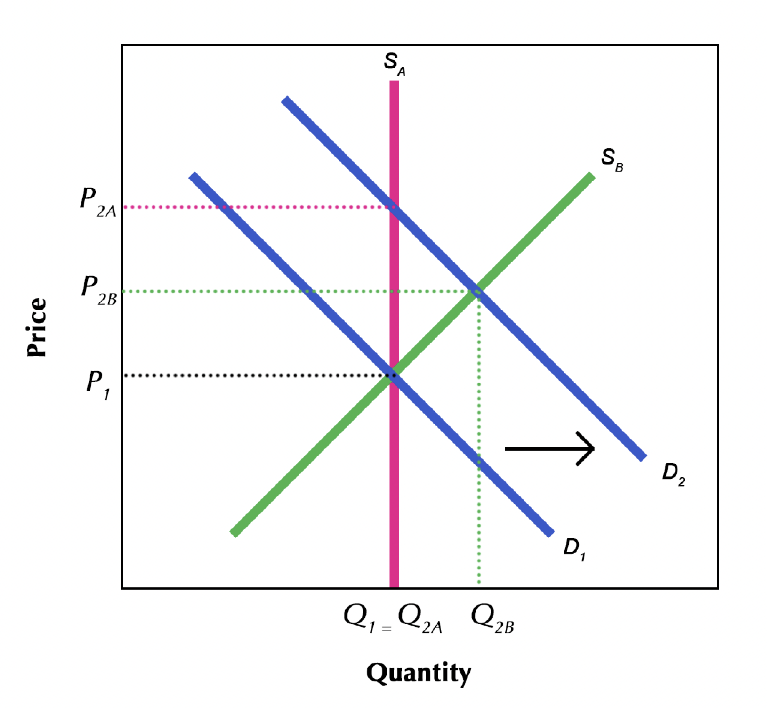
- Refer to Sources A, B and C, and D. Suggest TWO reasons why some people prefer using 9999 gold instead of Bitcoin as money.
Suggested Answer:
Medium of exchange / Generally accepted: Gold is more generally accepted
Store of value: Price fluctuation in Bitcoin - price may decrease (significantly), causing lower purchasing power in the future.

- Refer to Source E and Source G. Which TWO properties of money that Bitcoin satisfies?
Suggested Answer:
Divisibility: the smallest unit of Bitcoin is satoshi (0.00000001 BTC), easily divisible
Scarcity: the long-run supply is fixed and limited. Growth of the quantity of Bitcoin is increasingly slow
Homogeneity: Bitcoin is perfectly homogenous

- Refer to Sources J and K. How would occupational labour mobility be impacted if virtual banks become more popular?
Suggested Answer:
Occupational Mobility: Lower level of occupational mobility may result due to a higher requirement of hard technical skills.

Advanced Level (Students are required to combine the information from the Sources and their own economic knowledge to answer these questions)
- Refer to Sources B, D, F, H and I and your knowledge in Economics. If you were a local merchant, would you choose Faster Payment System or Bitcoin as an online payment method? Explain your answers.
Suggested Answer:
A merchant may choose an online payment method of Faster Payment System (FPS) as (1) HKD is a legal tender and is widely accepted in Hong Kong, (2) FPS is more generally accepted, (3) Bitcoin value is highly volatile – not a good store of value, (4) any other relevant points. On the other hand, a merchant may choose an online payment method of Bitcoin as (1) it supports cross-border payment (for the international market), (2) provides investment opportunities, (3) any other relevant points.

- Refer to Sources E and F. Discuss the possible impacts of adopting Bitcoin as money in an economy, including its price level and economic growth.
Suggested Answer:
The inflexibly slow growth (or even zero growth in the future) in Bitcoin supply could create deflationary pressure on the economy. This can be explained by the quantity theory of money $MV=PY$. Given V is fixed, with slow growth (or fixed amount) in M, the growth of the economy at a rate larger than the money supply growth will inevitably result in a decrease in the price level (i.e., increase in Bitcoin value’s) as a general phenomenon. The expectation of deflation could suppress economic growth as consumption may decrease when people expect a fall in the general price level in the future. Also, without the direct control over the money supply, it’s more difficult for the government to fine-tune the economy using monetary policies in response to shocks in aggregate supply and aggregate demand. Although the supply of Bitcoin is limited, it is possible for the software to be modified to provide an even smaller unit of Bitcoin as a unit of account for transaction (currently smallest unit is 1 “sathoshi” = 1/100000000 Bitcoin). However, Bitcoin itself does not have any intrinsic value. It is not backed by any bank or government, nor supported by its issuers. Any unfavourable news about Bitcoin, for example unknown future bugs in the software or loss of trust in the cryptocurrency, would cause financial crises and negatively impact the economy significantly.

Reference websites for this topic
Bank for International Settlements | www.bis.org
Bitcoin Project | Bitcoin.org
Census and Statistics Department | www.statistics.gov.hk
CoinMarketCap | coinmarketcap.com
Research Division of the Federal Reserve Bank of St. Louis | research.stlouisfed.org
Hong Kong Monetary Authority | www.hkma.gov.hk
Insurance Authority | www.ia.org.hk
International Monetary Fund | www.imf.org
Investor and Financial Education Council | www.ifec.org.hk
Libra Association | libra.org

What is Bitcoin? An eight-step guide to the cryptocurrency (n.d.) https://www.bbc.co.uk/bitesize/articles/zfsvy9q
Frankenfield J (2020, May 5) Cryptocurrency Definition. https://www.investopedia.com/terms/c/cryptocurrency.asp
Guide: What is Bitcoin and how does Bitcoin work? – CBBC Newsround (2018, October 31) Retrieved from https://www.bbc.co.uk/newsround/25622442
Investor and Financial Education Council (n.d.) ICO, Bitcoin and other “Cryptocurrencies” Retrieved from https://www.ifec.org.hk/web/en/financial-products/fintech/ico-Bitcoin/ico-Bitcoin-cryptocurrencies.page
Cryptocurrency and Bitcoin for beginners: what you need to know about it (2018, March 21). https://medium.com/@northof41/cryptocurrency-and-Bitcoin-for-beginners-what-you-need-to-know-about-it-1fb44c2667f4
What is Bitcoin? An eight-step guide to the cryptocurrency (n.d.) https://www.bbc.co.uk/bitesize/articles/zfsvy9q
Chohan U. W. (2017). The Double-Spending Problem and Cryptocurrencies
CoinMarketCap.com (2022) All Cryptocurrencies. https://coinmarketcap.com/all/views/all/
Chen J. (2020) Market Capitalization. https://www.investopedia.com/terms/m/marketcapitalization.asp
blockchain.com (2020) Confirmed Transactions Per Day. https://www.blockchain.com/charts/n-transactions
Investor and Financial Education Council (n.d.) Basic concept – Blockchain. https://www.ifec.org.hk/web/en/financial-products/fintech/ico-Bitcoin/basic-concept-blockchain.page
Kelly, B. (2014) The Bitcoin Big Bang: How Alternative Currencies Are About to Change the World. p.10
Nakamoto, S. (2009, February 11) Bitcoin open source implementation of P2P currency. https://p2pfoundation.ning.com/forum/topics/Bitcoin-open-source
Bitcoin Project (n.d.) Frequently Asked Questions https://Bitcoin.org/en/faq
Guide: What is Bitcoin and how does Bitcoin work? – CBBC Newsround (2018, October 31) https://www.bbc.co.uk/newsround/25622442
Bitcoin Wiki (n.d.) Controlled supply https://en.Bitcoin.it/wiki/Controlled_supply
Federal Reserve Bank of St. Louis (2022) M1 Money Stock https://fred.stlouisfed.org/series/M1SL
Bitcoin Project (n.d.) Frequently Asked Questions. https://Bitcoin.org/en/faq
Coppola F. (n.d.) Pros and Cons of Bitcoin for International Payments. https://www.americanexpress.com/us/foreign-exchange/articles/Bitcoin-a-part-of-the-international-payments-landscape/
Microsoft (2018) How to use Bitcoin to add money to your Microsoft account. https://support.microsoft.com/en-us/help/13942/microsoft-account-how-to-use-Bitcoin-to-add-money-to-your-account
Beliani.hu (n.d.) Payment https://www.beliani.ch/content/payment/
Newegg Inc (n.d.) Using BitPay on Newegg. https://kb.newegg.com/?s=Bitcoin&ht-kb-search=1
Menufy (2018.) Order food with Bitcoin & Bitcoin Cash. https://restaurant.menufy.com/article/2018/order-food-with-Bitcoin-and-Bitcoin-cash
BitPay (n.d.) Welcome to the future of payments. https://bitpay.com/online-payments/
Investor and Financial Education Council (n.d) Basic concept - Bitcoin/"cryptocurrencies" https://www.ifec.org.hk/web/en/financial-products/fintech/ico-Bitcoin/basic-concept-Bitcoin.page
Kharif, O. (2019, May 31) Bitcoin’ Rally Masks Uncomfortable Fact: Almost Nobody Uses It. Bloomberg. https://www.bloomberg.com/news/articles/2019-05-31/Bitcoin-s-rally-masks-uncomfortable-fact-almost-nobody-uses-it?srnd=cryptocurrencies
Decentralized, Peer-to-peer, Cryptocurrency (n.d.) https://cs.stanford.edu/people/eroberts/courses/cs181/projects/2010-11/DigitalCurrencies/disadvantages/index.html
Bitcoin Project (n.d.) Frequently Asked Questions. https://Bitcoin.org/en/faq
Elwell, C. K., Murphy M. M. and Seitzinger M. V. (2015) Bitcoin: Questions, Answers, and Analysis of Legal Issues. CRS Reports Retrieved from https://pdfs.semanticscholar.org/6d33/13fe23a95f16b6ea2b5908e274b487106e5e.pdf
Krugman, P. (2011, September 7). Golden Cyberfetters. New York Times.
Greco T.H. (2001) Money: Understanding and Creating Alternatives to Legal Tender. White River Junction, Vermont: Chelsea Green Publishing.
Ciaian P., Rajcaniova M. and Kancs D (2015) The economics of Bitcoin price formation. Applied Economics, Vol 48, Issue 19, pp. 1799-1815.
Putnam, B. and Norland, E. (2018, April 24) An In-Depth Look at the Economics of Bitcoin. https://www.cmegroup.com/education/featured-reports/an-in-depth-look-at-the-economics-of-Bitcoin.html
He, D. (2018) Monetary Policy in the Digital Age. FINANCE & DEVELOPMENT, Vol 55, No. 2 https://www.imf.org/external/pubs/ft/fandd/2018/06/central-bank-monetary-policy-and-cryptocurrencies/he.htm
Foley, S., Karlsen, J. R., and Putniņš, T. J. (2019) Sex, Drugs, and Bitcoin: How Much Illegal Activity Is Financed through Cryptocurrencies. The Review of Financial Studies, Vol 32, Issue 5, pp 1798–1853
Baraniuk, C. (2019, July 3) Bitcoin’s energy consumption 'equals that of Switzerland' BBC News https://www.bbc.com/news/technology-48853230
Libra Association (2020) Libra White Paper v2.0 https://libra.org/en-US/white-paper
Bank for International Settlements (2018) Central bank digital currencies. https://www.bis.org/cpmi/publ/d174.pdf
Dimitrov, B. (2020, April 16) These Chinese Blockchain Platforms Are Launching Soon, Here Is Why. Forbes https://www.forbes.com/sites/biserdimitrov/2020/04/16/these-chinese-blockchain-platforms-are-launching-soon-here-is-why/#1d9b2f35207e
CoinMarketCap.com (2022) Bitcoin (BTC) historical data. https://coinmarketcap.com/currencies/bitcoin/historical-data/
Bitcoin Wiki (n.d.) Satoshi (unit). https://en.Bitcoin.it/wiki/Satoshi_(unit)
Gold Price Historical Data | Gold Price History | World Gold Council (2020) https://www.gold.org/goldhub/data/gold-prices
Foreign Exchange Rates (2020) https://www.federalreserve.gov/releases/h10/Hist/dat00_eu.htm
Bitcoin price today, BTC live marketcap, chart, and info | CoinMarketCap (2020) https://coinmarketcap.com/currencies/Bitcoin/historical-data/
Census and Statistics Department, Hong Kong Special Administrative Region (2020) Hong Kong Monthly Digest of Statistics - The Financial Services Sector in Hong Kong. https://www.statistics.gov.hk/pub/B72004FB2020XXXXB0100.pdf
Hong Kong Monetary Authority Fintech.https://www.hkma.gov.hk/eng/key-functions/international-financial-centre/fintech/
Hong Kong Monetary Authority Fintech.https://www.hkma.gov.hk/eng/key-functions/international-financial-centre/fintech/
Hong Kong Monetary Authority Smart Banking. https://www.hkma.gov.hk/eng/key-functions/banking/smart-banking/
Hong Kong Monetary Authority Virtual Banks. https://www.hkma.gov.hk/eng/key-functions/banking/banking-regulatory-and-supervisory-regime/virtual-banks/
Hong Kong Monetary Authority List of virtual banks. https://www.hkma.gov.hk/media/eng/doc/key-functions/banking-stability/banking-policy-and-supervision/List_of_virtual_banks(1Apr2022)(Eng).xlsx
Investor and Financial Education Council How do I open an account, deposit money into and withdraw money from a virtual bank? https://www.ifec.org.hk/web/en/financial-products/fintech/virtual-bank/how-to-open-account-from-virtual-bank.page
Hong Kong Monetary Authority Guideline on Authorization of Virtual Banks. https://www.hkma.gov.hk/eng/news-and-media/press-releases/2018/05/20180530-3/
Lee, G. (2019, May 16) BOCHK’s virtual bank is a new paradigm that transcends old business models. South China Morning Post. https://www.scmp.com/business/article/3010547/livi-vb-bochks-virtual-bank-operate-loss-initial-three-years-ceo-says
Hong Kong Institute for Monetary and Financial Research (2020) Fintech Adoption and Innovation in the Hong Kong Banking Industry. https://www.aof.org.hk/docs/default-source/hkimr/applied-research-report/fintechrep.pdf
Insurance Authority (2020) Fourth virtual insurer granted new authorization under Fast Track. https://www.ia.org.hk/en/infocenter/press_releases/20200504.html
Hong Kong Institute for Monetary and Financial Research (2020) Fintech Adoption and Innovation in the Hong Kong Banking Industry. https://www.aof.org.hk/docs/default-source/hkimr/applied-research-report/fintechrep.pdf
Hong Kong Monetary Authority (2016) Productivity Growth in Hong Kong: Sector Patterns and Drivers. https://www.hkma.gov.hk/media/eng/publication-and-research/research/research-notes/RN-02-2016.pdf
Census and Statistics Department, Hong Kong Special Administrative Region,Table 188 : Value added and employment in respect of the Four Key Industrieshttps://www.censtatd.gov.hk/en/web_table.html?id=188
Census and Statistics Department, Hong Kong Special Administrative Region (2019) Report on Manpower Projection to 2027. Retrieved from https://www.statistics.gov.hk/pub/B1050016E2019XXXXE0100.pdf
Census and Statistics Department, Hong Kong Special Administrative Region (2020) Report on Manpower Projection to 2027. https://www.statistics.gov.hk/pub/B1050016E2019XXXXE0100.pdf
Wolla, S. (2018) Bitcoin: Money or Financial Investment? PAGE ONE Economics\https://research.stlouisfed.org/publications/page1-econ/2018/03/01/Bitcoin-money-or-financial-investment
Putnam, B. and Norland, E. (2018, April 24) An In-Depth Look at the Economics of Bitcoin https://www.cmegroup.com/education/featured-reports/an-in-depth-look-at-the-economics-of-Bitcoin.html

